Johnny Li

EEL3111C

Tuesday P.10-11

Lab 8-Write Up

Introduction

The goal of this lab is to explore was to see how diodes work in a circuit. Such applications include being an indicator for the direction of current, clip detection, and rectification. Diodes are mainly implemented to ensure that not too much current goes through else the diode acts as an open circuit.

Discussion

8.6.1 Breadboard Implementation

1. Figure 1: The input voltage and the voltage at a comparator from Figure 8.4 in the lab manual. The circuit diagram included.

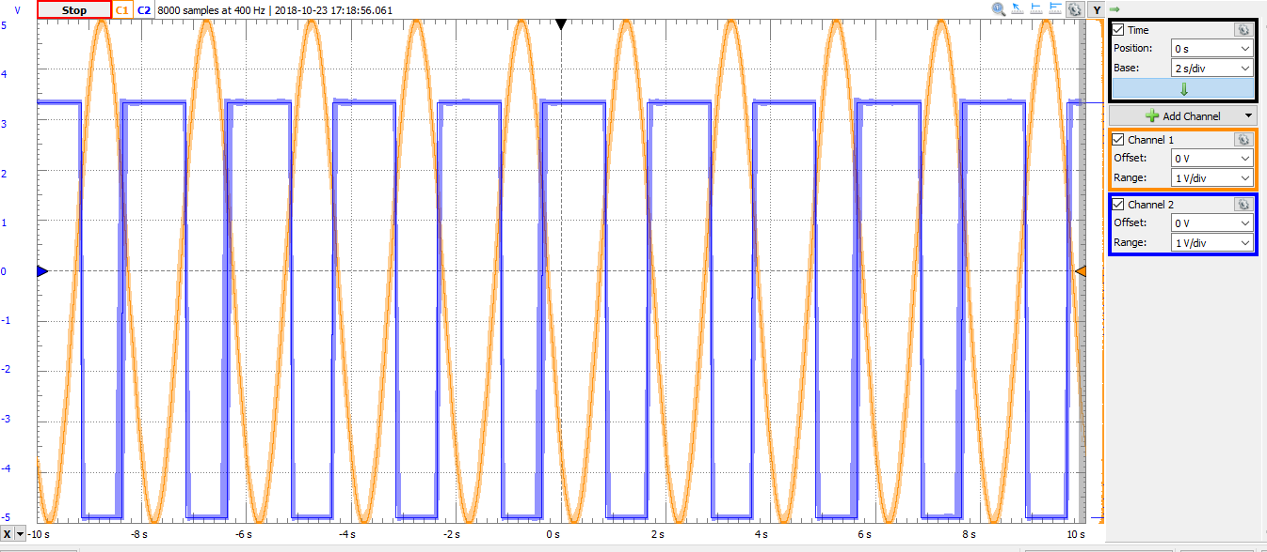

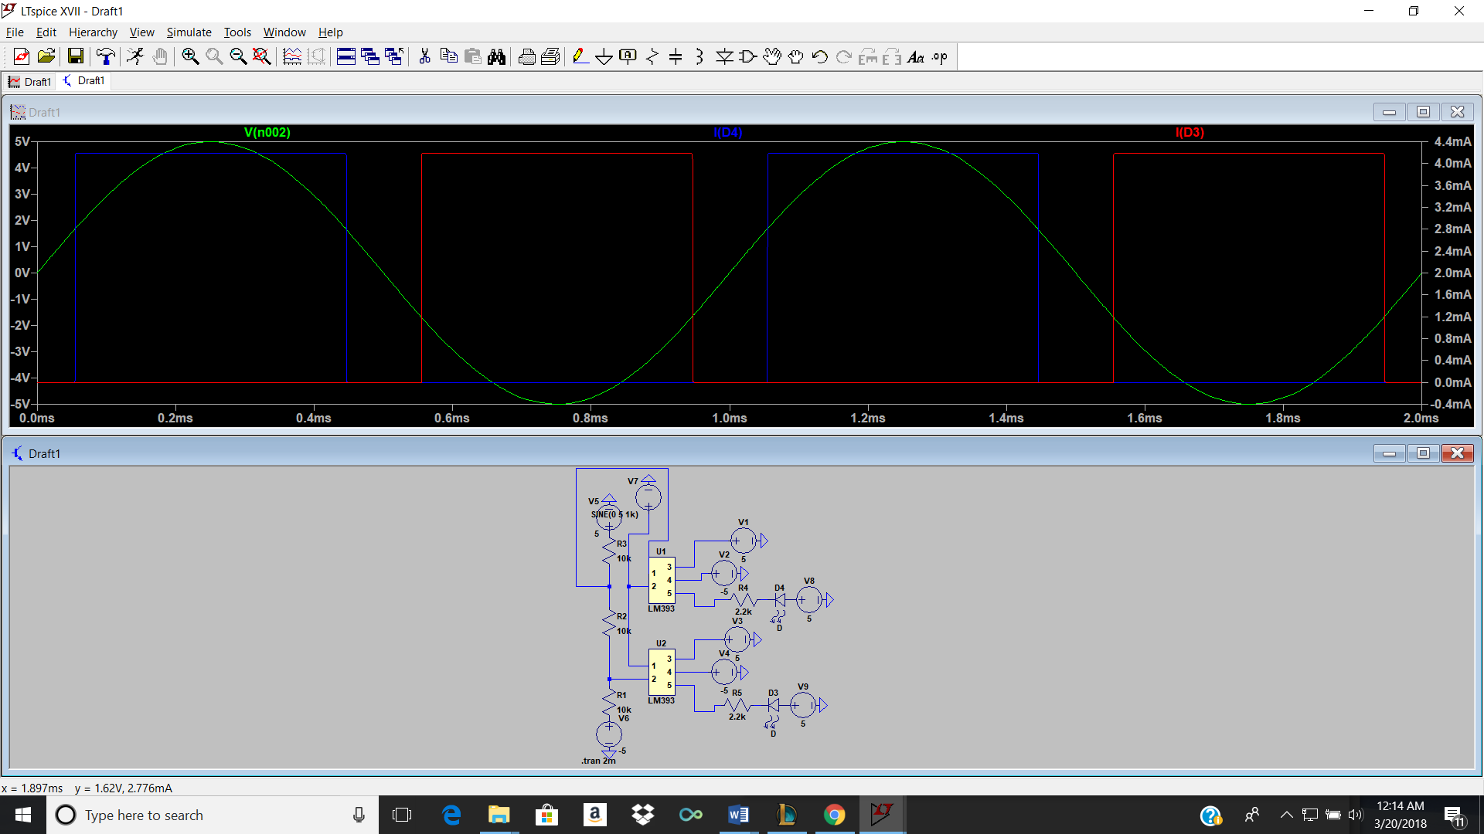

This is clipping detection circuit used to indicate that the output of the op amp is clipping without through an LED. The circuit is limited by forward voltage which limits how much of the signal can be rectified. When the sinusoid is equal to minimum value, the output of the diode either goes to its maximum output, thus lighting up, and vice versa.

2. Figure 2: The input voltage and output from Section 8.5.1 - Item 1 in the lab manual. The circuit diagram included.

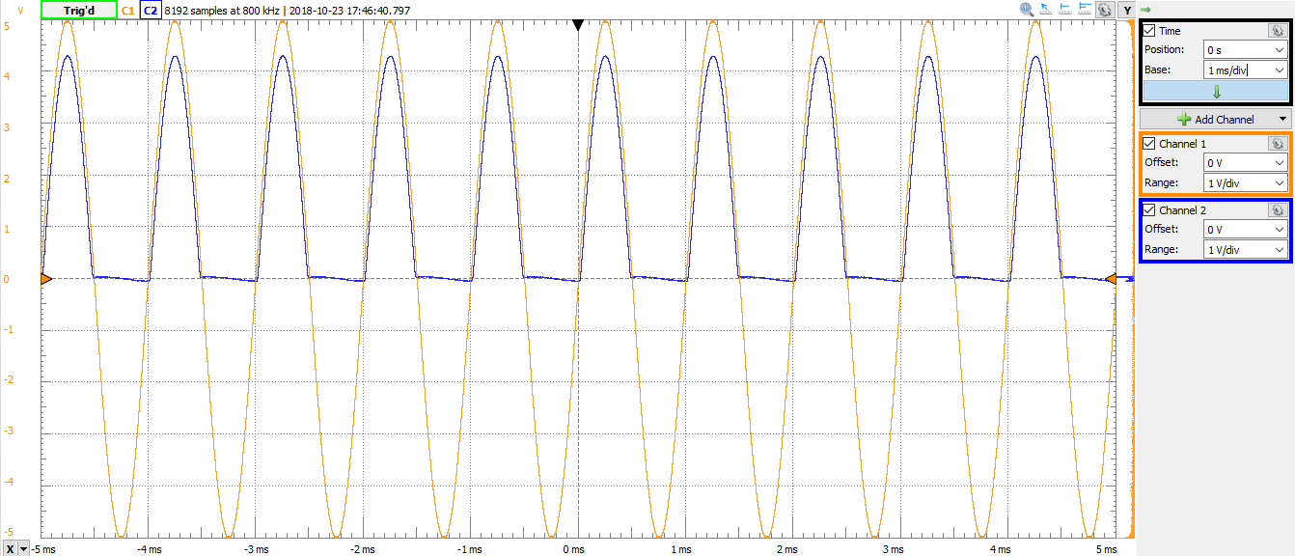

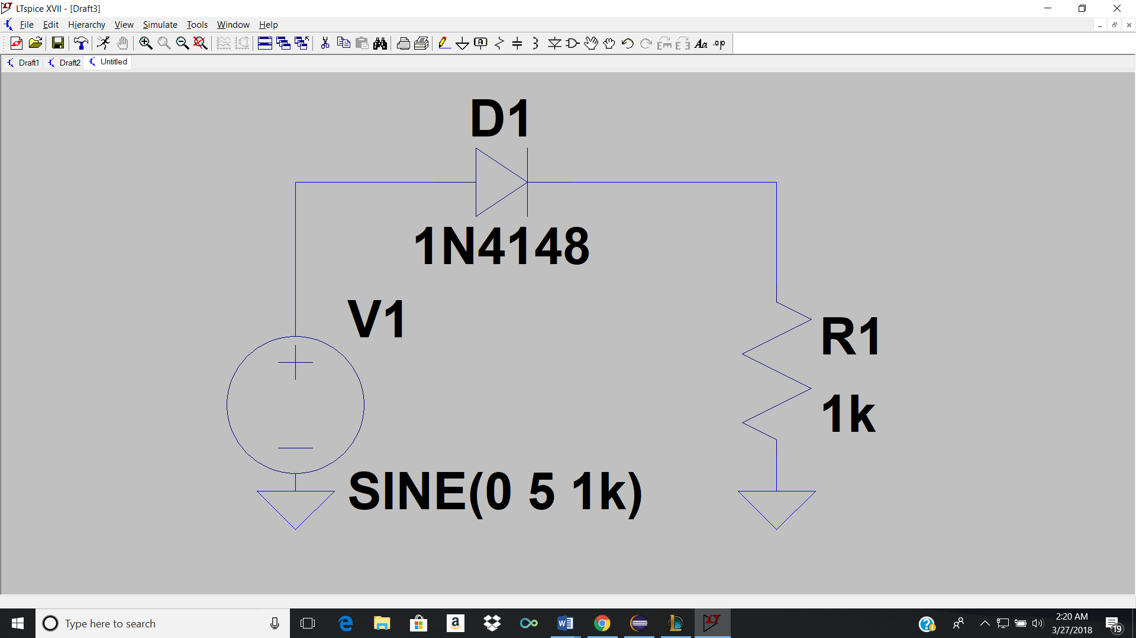

This is a simple half wave rectifier where the sinusoid and the diode will rise and fall relative to each other. A diode reacts to changes in current but when the sinusoid becomes negative the diode will no longer respond and the output of the diode becomes zero. This is because a diode cannot exist at a negative current in which it becomes an open circuit.

3. Figure 3: The input voltage and output from Section 8.5.1 - Item 2 in the lab manual with the 0.1uF capacitor. The circuit diagram included.

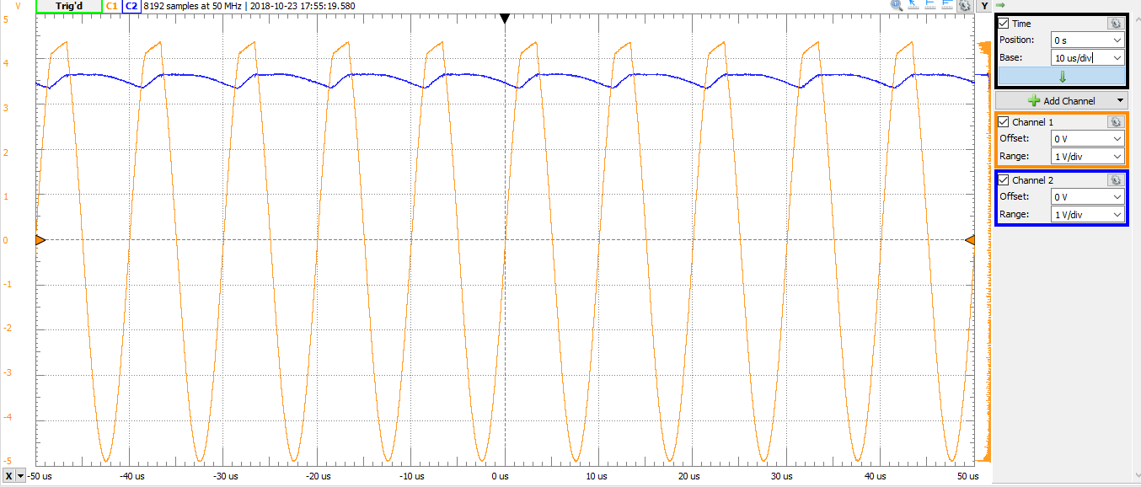

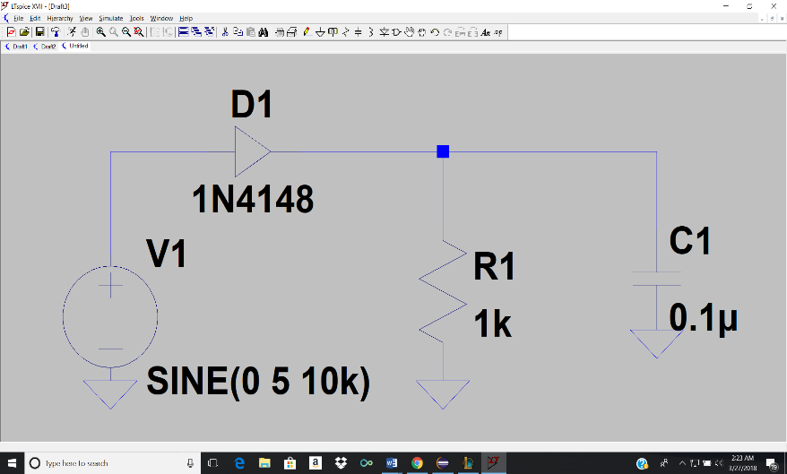

Figure 4: The input voltage and output from Section 8.5.1 - Item 2 in the lab manual with the 0.01uF capacitor. The circuit diagram included.

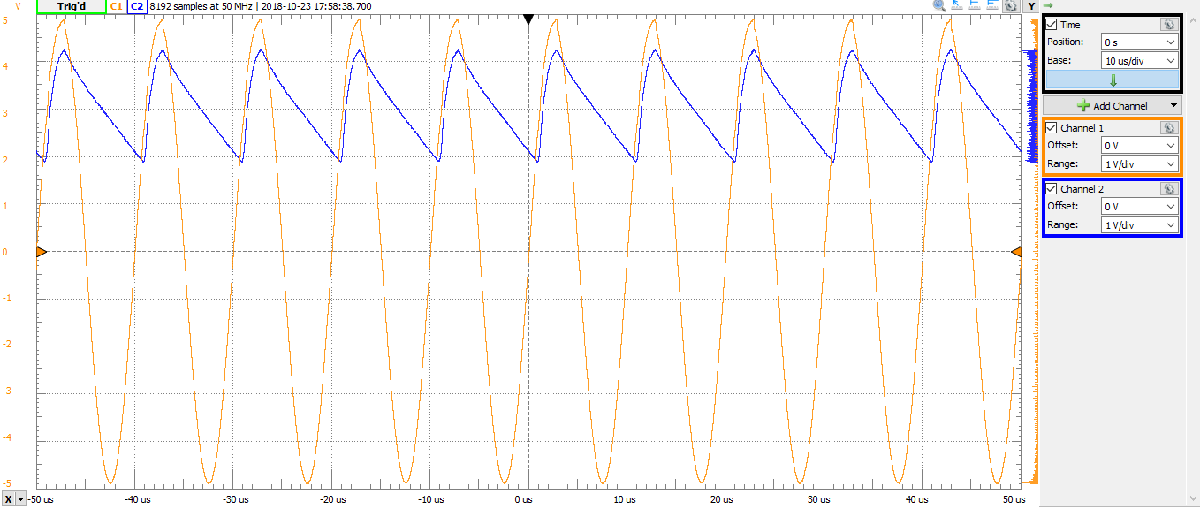

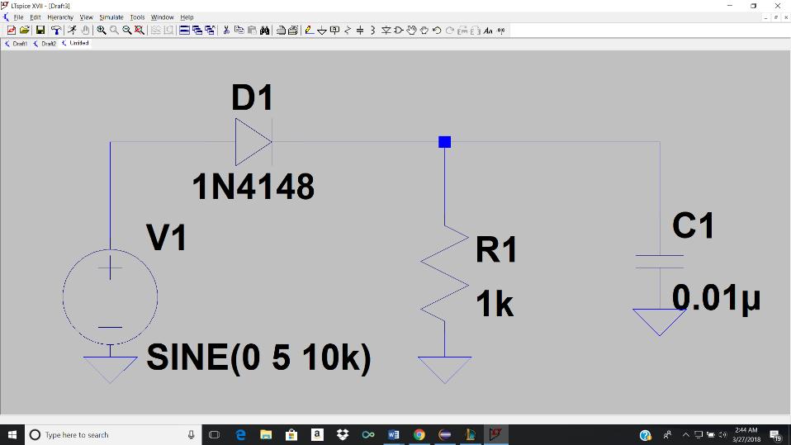

This circuit is a simple half wave rectifier but with a capacitor at the output. The outputs of both circuits are generally the same but there is a deeper drop in the voltage in the circuit with the smaller capacitor because it has less stored energy as opposed to the larger capacitor which takes less time to discharge completely and therefore can’t maintain the larger steady output voltage.

4. Figure 4: The output of the gain amplifier and the voltage at a comparator from Section 8.5.1 - Item 4 in the lab manual. The circuit diagram included.

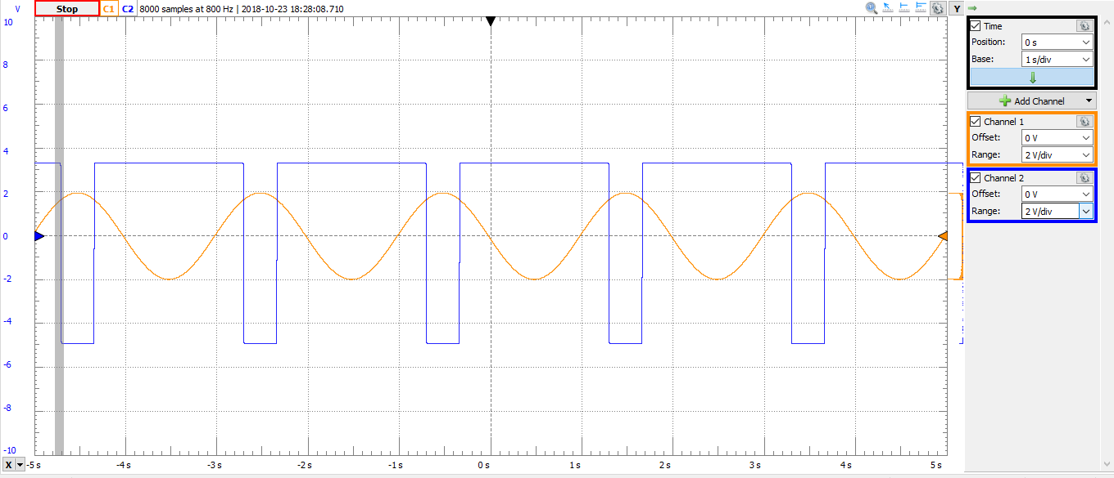

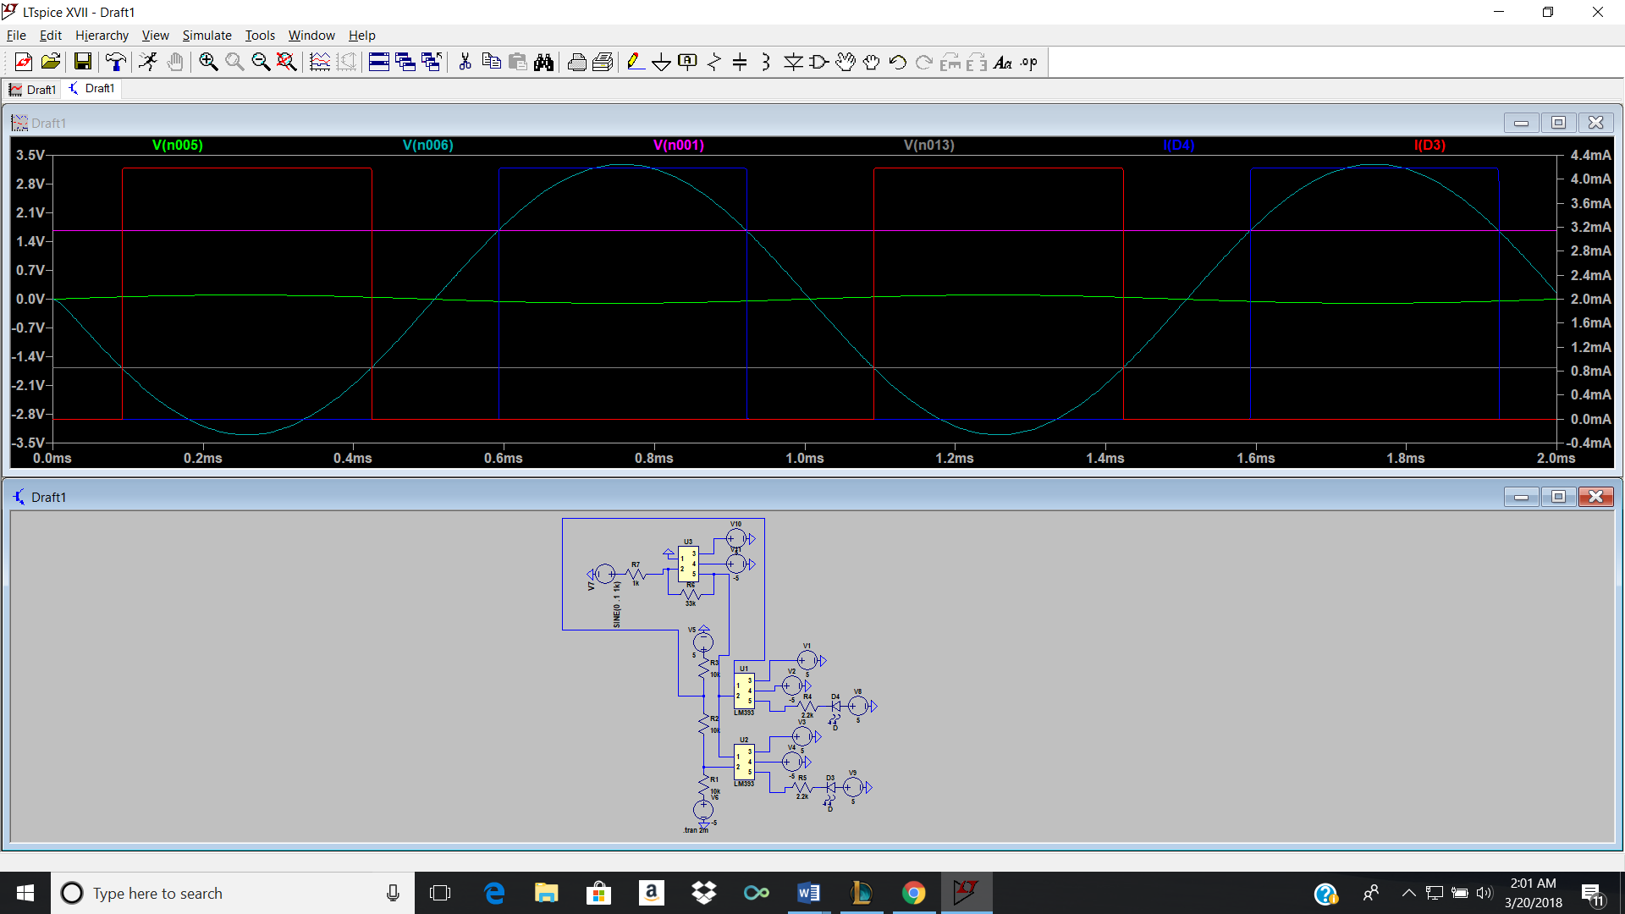

This circuit is a variable gain amplifier with a potentiometer, where the output is checked for clipping. The input current was set to be larger than the gain of the circuit, because there is a larger gain going through the circuit, the comparator stays at its highest value for longer and goes to its lowest value for a shorter period.

Conclusion:

In conclusion, the lab focused on diodes and some of their many functions. Some are implemented in the physical circuits build or in the simulations. The use of diodes as indicators, voltage protection elements, and rectification were specifically taught in this lab.